

**Information Security IA1**

**BurpSuite**

Submitted

by

**Zayaan Ghauri**

Roll No: 16010122058

**Dhruv Desai**

Roll No: 16010122038

**Daksh Girdhar**

Roll No: 16010122059

Class- A-2

**Department of Computer Engineering**

**K. J. Somaiya College of Engineering**

**(Constituent College of Somaiya Vidyavihar University)**

**List of Tables**

|  |  |  |
| --- | --- | --- |
| **Sr. No** | **Title** | **Page No.** |
| **1.** | **Overview** | **3** |
| **2.** | **Features of Burp Suite** | **3** |
| **3.** | **Burp Suite Installation** | **4** |
| **4.** | **Burp Proxy** | **7** |
| **5.** | **Burp Repeater** | **10** |
| **6.** | **Burp Intruder** | **12** |
| **7.** | **Burp Encoder/ Decoder** | **15** |
| **8.** | **Burp Comparer** | **16** |
| **9.** | **Burp Target** | **17** |
| **10.** | **Limitations** | **18** |
| **11.** | **Conclusion** | **19** |

**Overview:**

Burp Suite, developed by PortSwigger, is a widely used penetration testing tool for identifying and exploiting web application vulnerabilities. Written in Java, it acts as an intermediary between a browser and the target server, enabling users to intercept, analyze, and manipulate HTTP/HTTPS traffic. It is essential for security professionals conducting web security assessments, aiding in detecting vulnerabilities like SQL Injection, Cross-Site Scripting (XSS), and authentication flaws. With both automated and manual testing features, Burp Suite provides a comprehensive security evaluation.

**Features of Burp Suite:**

Burp Suite provides an extensive range of tools tailored for web security testing and penetration testing. It empowers security professionals to intercept, analyze, and manipulate web traffic, making it a cornerstone tool for ethical hacking and penetration testing:

* **Proxy**: The Burp Proxy tool allows users to intercept and modify HTTP/HTTPS requests and responses between the client (browser) and the web server. It enables testers to analyze and manipulate requests for security testing purposes, such as injecting malicious payloads, modifying session tokens, and observing responses.
* **Intruder**: Burp Intruder is an automated tool designed for brute force attacks, fuzzing, and injection attacks. It facilitates the testing of web application vulnerabilities by inserting payloads into predefined positions within an HTTP request. It is commonly used for password brute-forcing, testing authentication mechanisms, and discovering hidden endpoints.
* **Target**: The Burp Target tool assists in managing findings and analyzing the structure of a web application. It provides a visual sitemap of the application, which is invaluable for planning penetration tests and defining the scope of testing.
* **Repeater**: The Burp Repeater tool enables users to manually modify and resend HTTP requests multiple times without needing to capture them again. This is particularly useful for testing vulnerabilities such as SQL injection, Cross-Site Scripting (XSS), and authentication bypass attacks.
* **Sequencer**: The Burp Sequencer tool analyzes session tokens and other data to assess their randomness and predictability. This is essential for evaluating the strength of authentication tokens and session management mechanisms.
* **Decoder**: Burp Decoder facilitates the encoding and decoding of data, including URL encoding, Base64 encoding, HTML entity encoding, and more. It also supports various hash decoding techniques such as MD5, SHA-256, and BLAKE2B-256, making it a valuable tool for security testing and forensic analysis.
* **Comparer**: Burp Comparer allows users to compare two sets of data, such as HTTP responses, requests, or binary data. It highlights differences between them, which is useful for analyzing changes in web application behavior during penetration testing.
* **Logger**: The Burp Logger records all web traffic generated during a testing session. It provides a real-time record of all requests and responses, which is helpful for debugging and tracking security vulnerabilities.

**Burp Suite Installation:**

1. Visit the [Official Burp Suite Download Page](https://portswigger.net/burp/communitydownload) and download the installation file.
2. Once downloaded, open the burpsuite_community_windows-x64.exe file and run the installer.
3. Follow the installation prompts, set the installation path, and click **Next**.
4. Allow the installer to complete the installation process.
5. Click **Finish** once the installation is complete.
6. 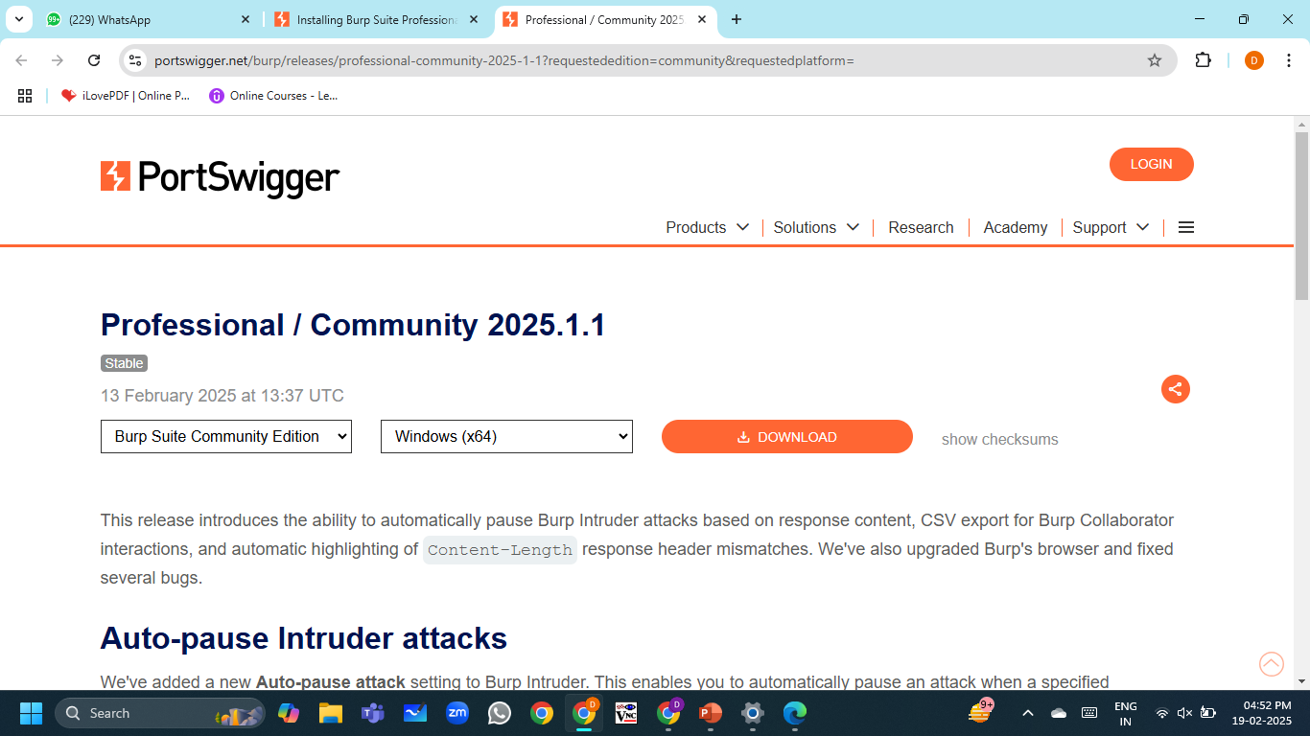
7. 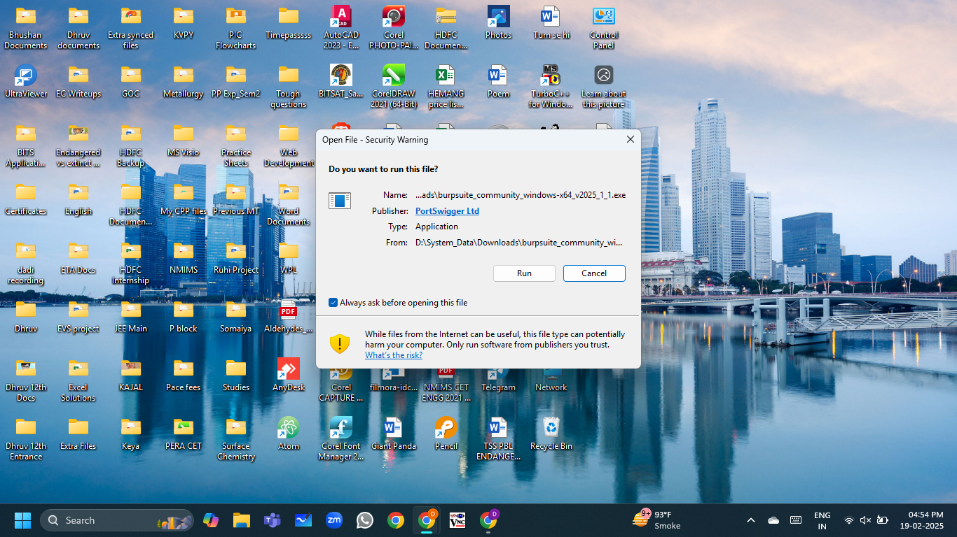
8. After completion, set the Installation path of Burp Suite and click Next.

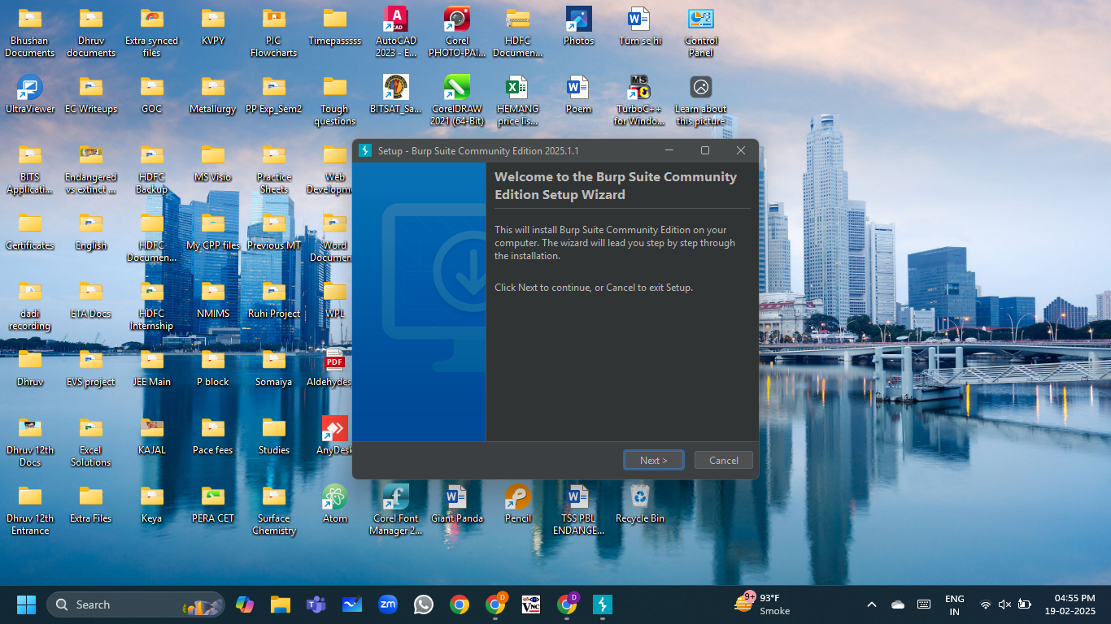

1. Allow it to install the application.

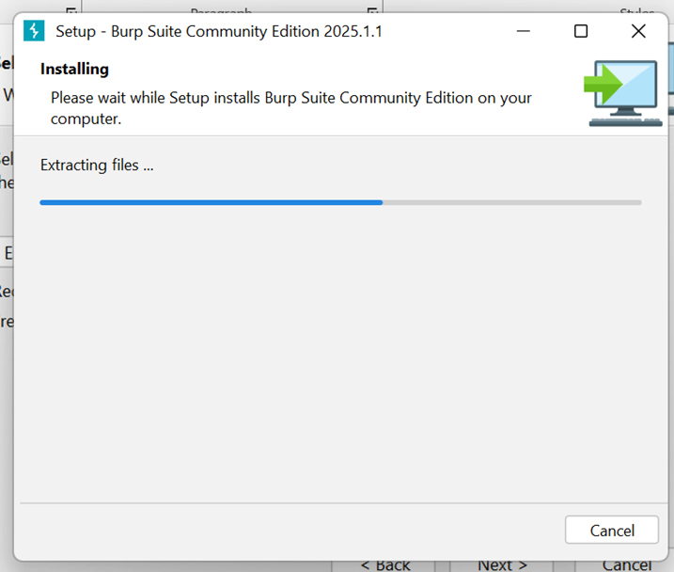

1. Click on Finish once the installation is complete.

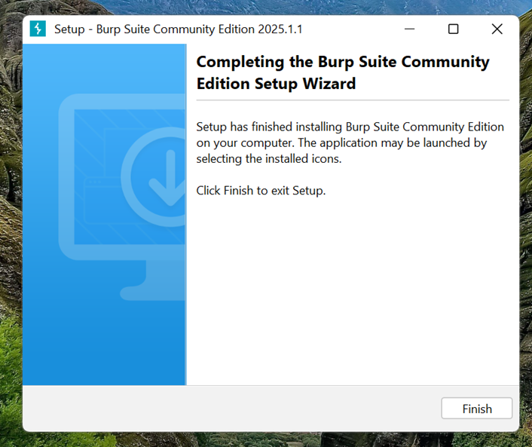

**Burp Proxy:**

Burp Proxy intercepts and modifies HTTP/S requests and responses between a client (browser) and a web server. It helps analyse traffic, test security vulnerabilities, and manipulate requests. It supports intercepting, modifying, and forwarding requests in real-time.

1. **Set Browser Proxy** to 127.0.0.1:8080 (manual proxy settings).

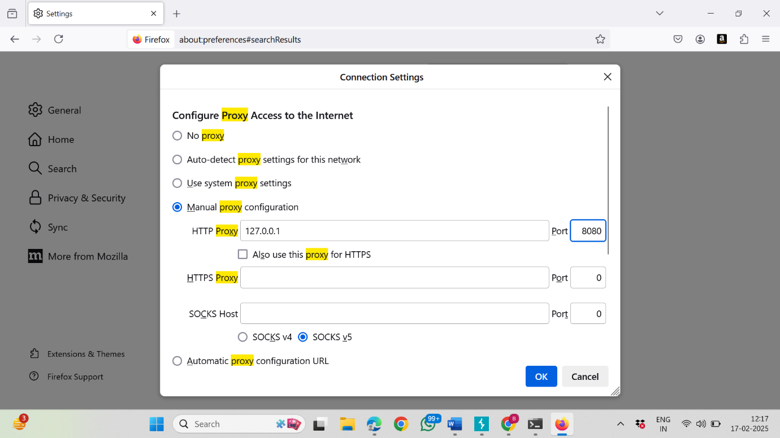

1. **Install Burp CA Certificate** from http://burpsuite (add to Trusted Root CA).

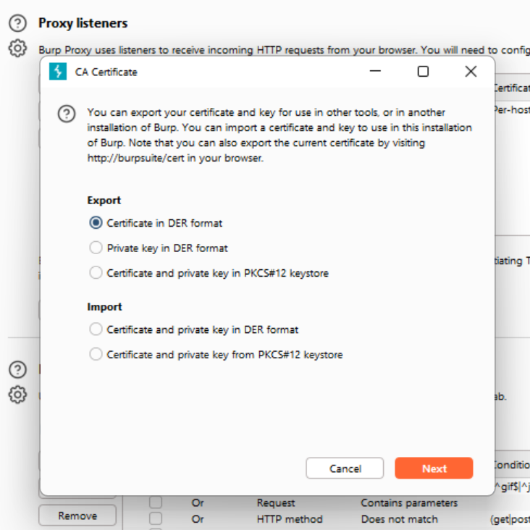

1. **Intercept HTTPS Traffic**: Enable **"Intercept is on"**, open a site, and capture requests.
2. 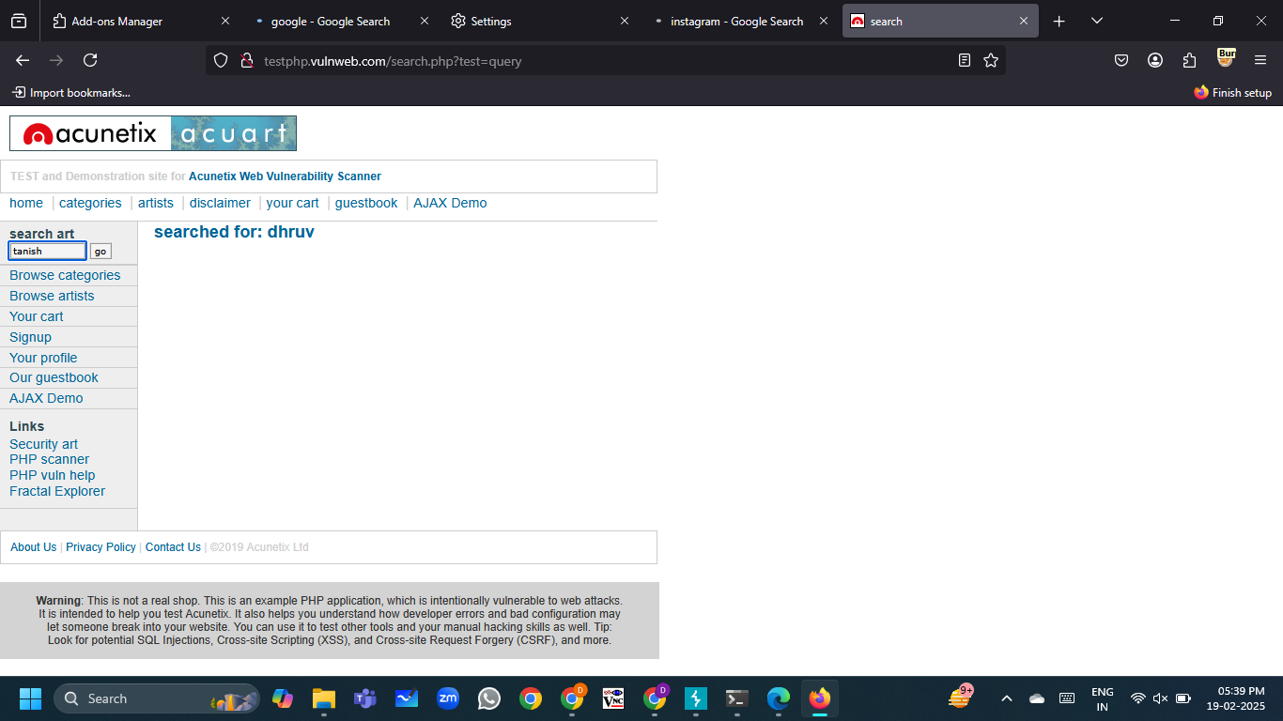

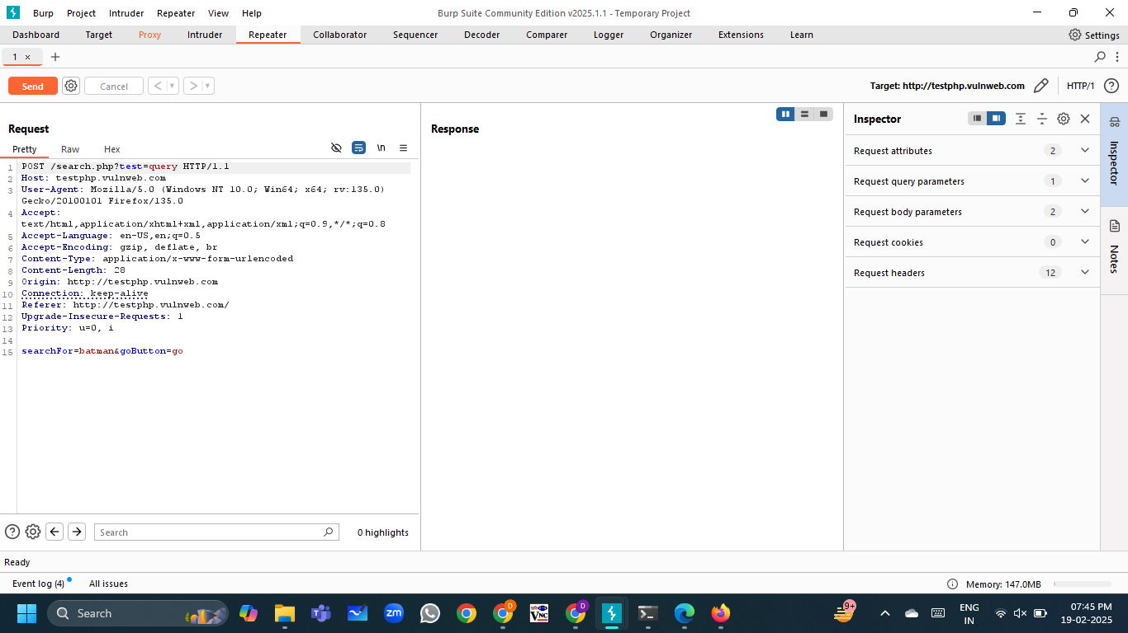

1. **Modify/Forward Requests** or analyse in **HTTP history**.
2. 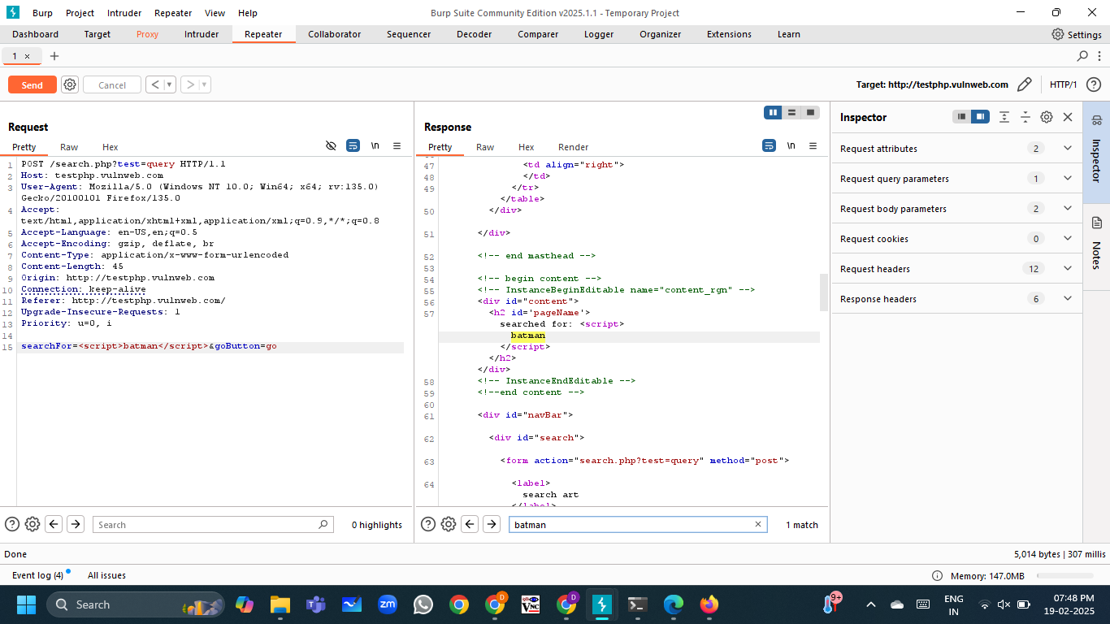

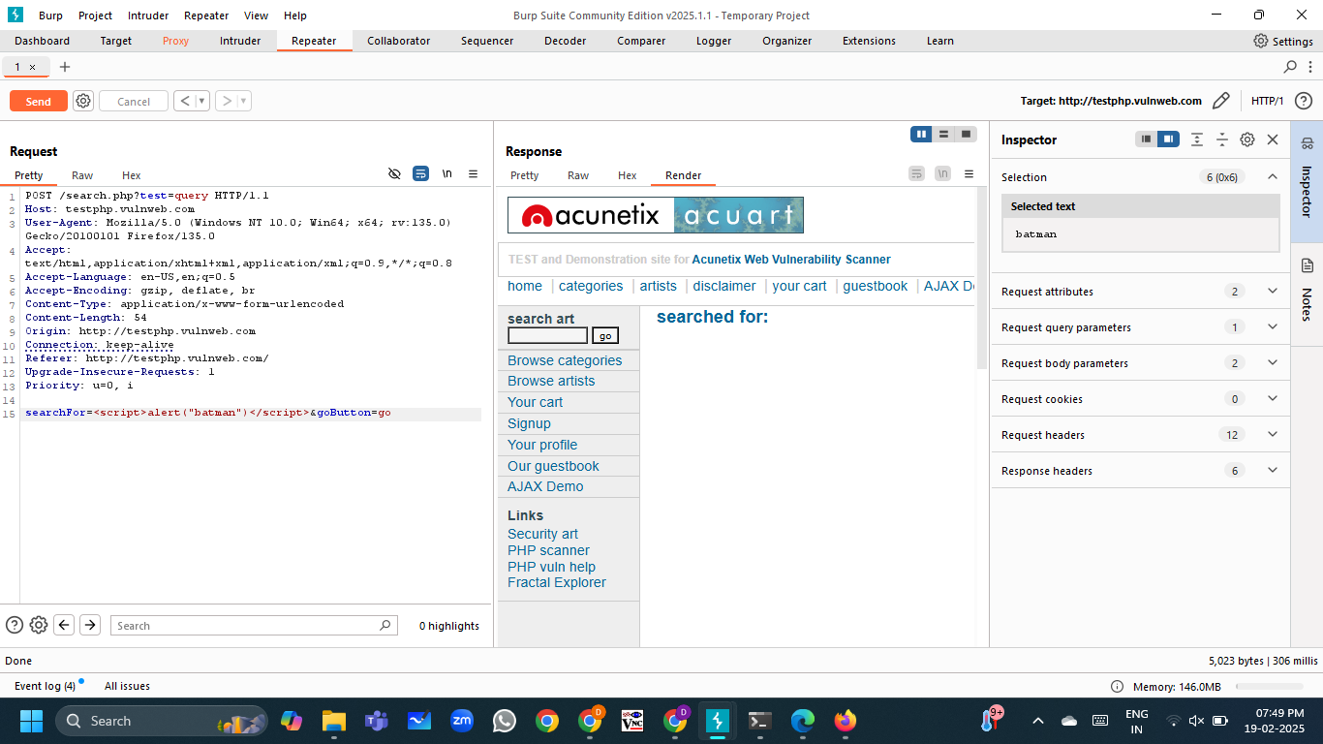

Burp Proxy is used for web application security testing, traffic analysis, and debugging API communications.

**Burp Repeater:**

1. **Burp Repeater is a manual testing tool within Burp Suite that allows users to modify and replay HTTP requests. It is particularly useful for testing authentication mechanisms, session handling, and vulnerabilities such as SQL injection, XSS, and IDOR.Capture a Request** – Enable **Intercept** in **Proxy**, visit a site, and let Burp grab the request.

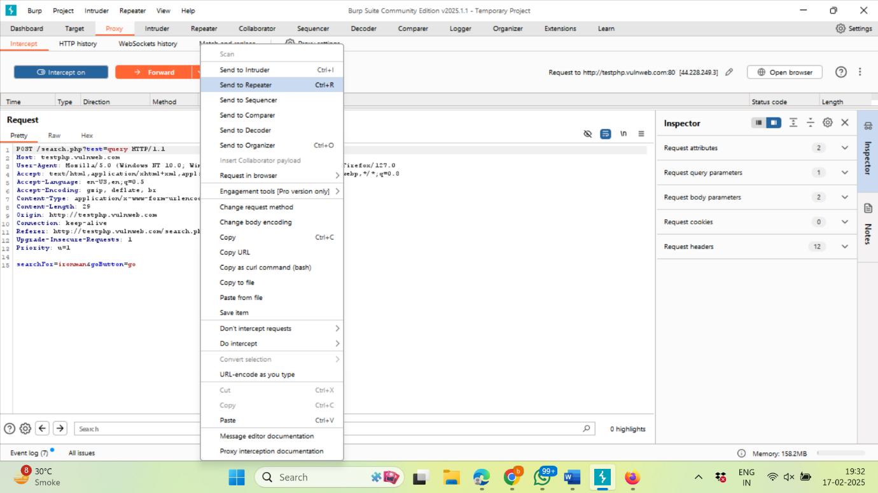

1. **Send to Repeater** and **Modify the Request** – Adjust headers, parameters, or payloads as needed.

* Script:

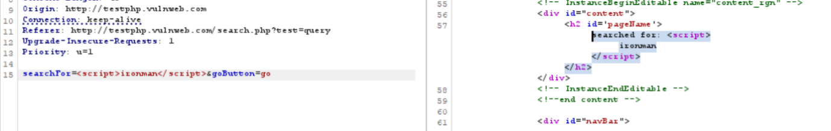

* Alert:

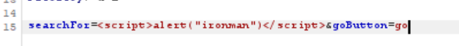

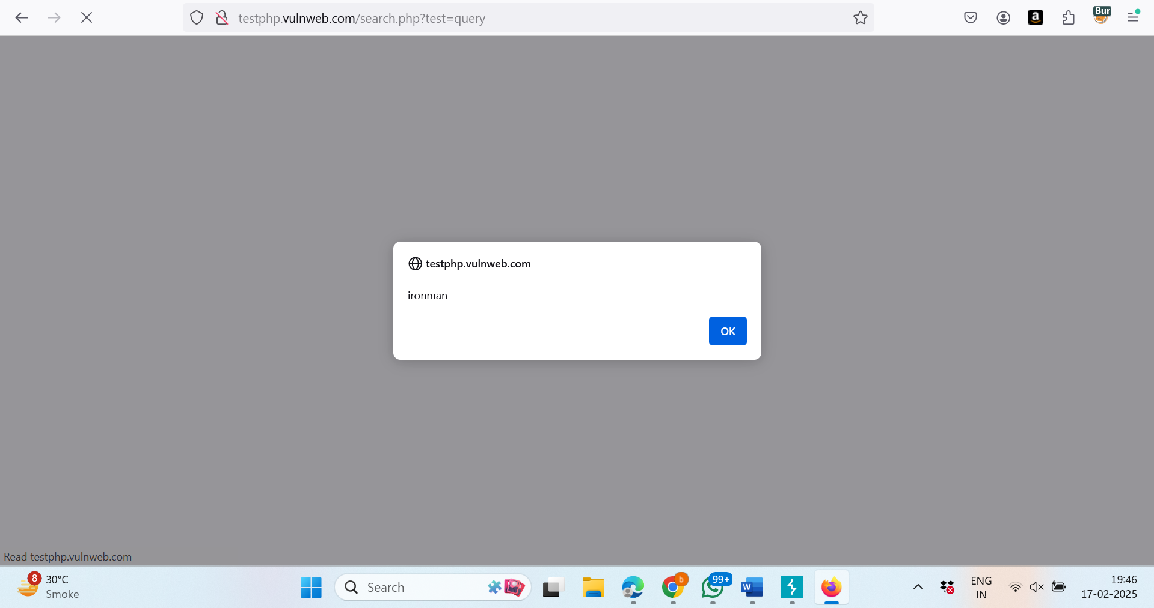

* Cookie:



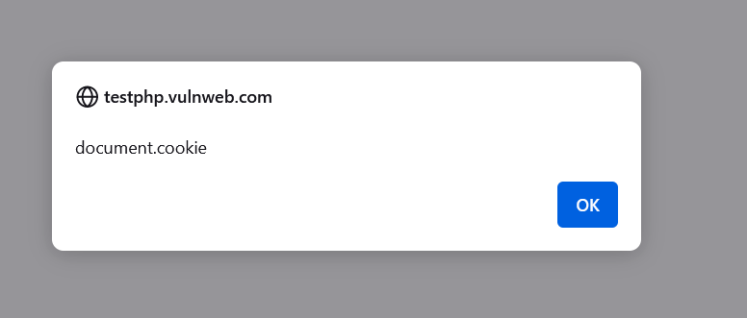

The requests and responses can also be views in different formats to analyse them while the data inside the request would remain the same.

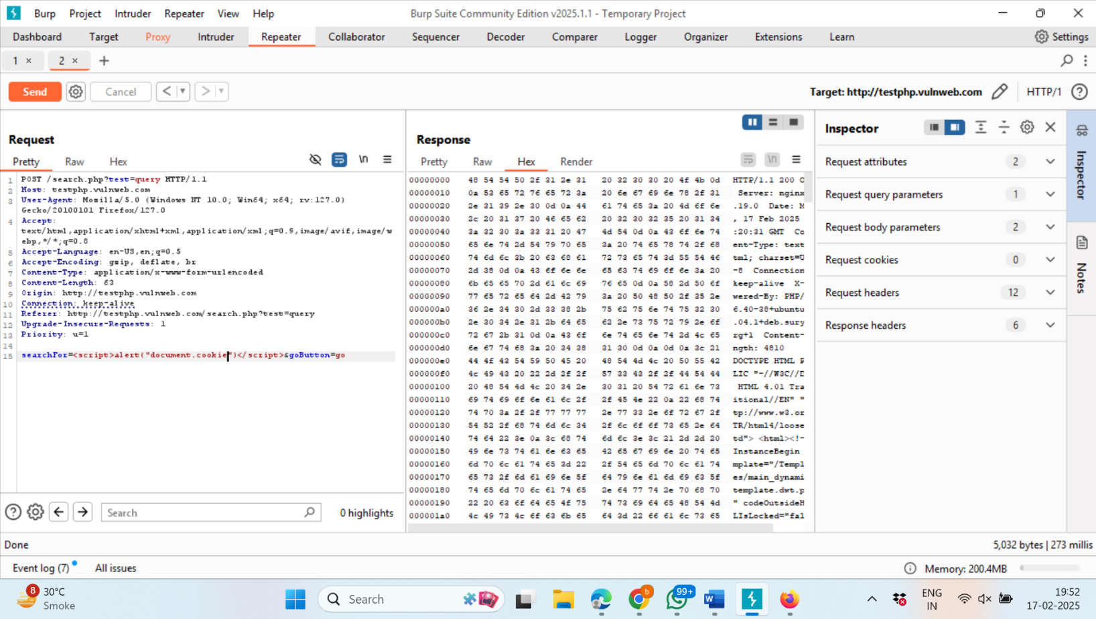

Burp Repeater is used for manual testing of web applications, parameter tampering, and debugging API behaviour.

**Burp Intruder:**

**Burp Intruder** automates the process of sending multiple requests with varying payloads to identify security flaws such as SQL injection, XSS, and brute-force vulnerabilities. It supports custom attack configurations and detailed response analysis.

Burp Intruder offers four types of attacks:

1. **Sniper**: Tests one parameter at a time.
2. **Battering Ram**: Uses the same payload across all positions.
3. **Pitchfork**: Utilizes multiple payload sets simultaneously.
4. **Cluster Bomb**: Tests all possible combinations of payloads.

.

1. Select a request and send it to Intruder.

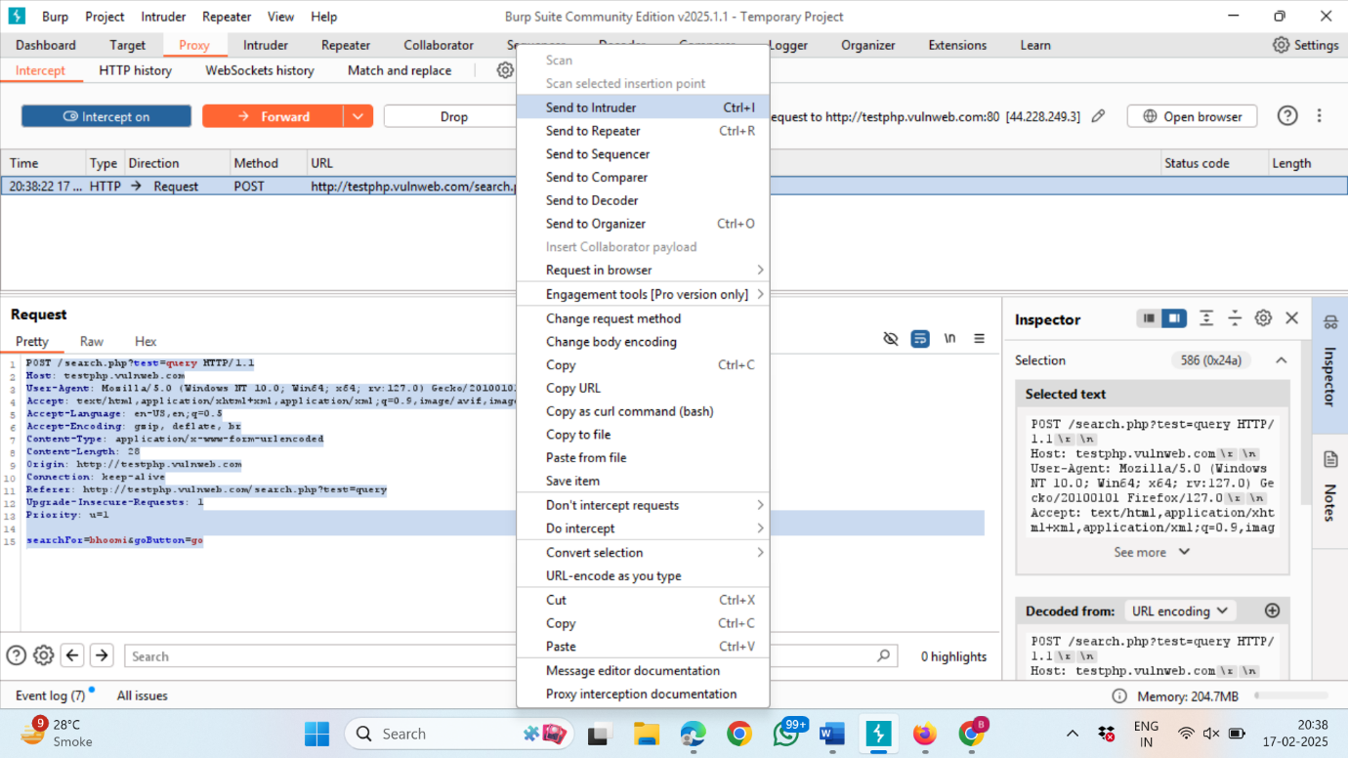

1. Load a payload list for testing different inputs.

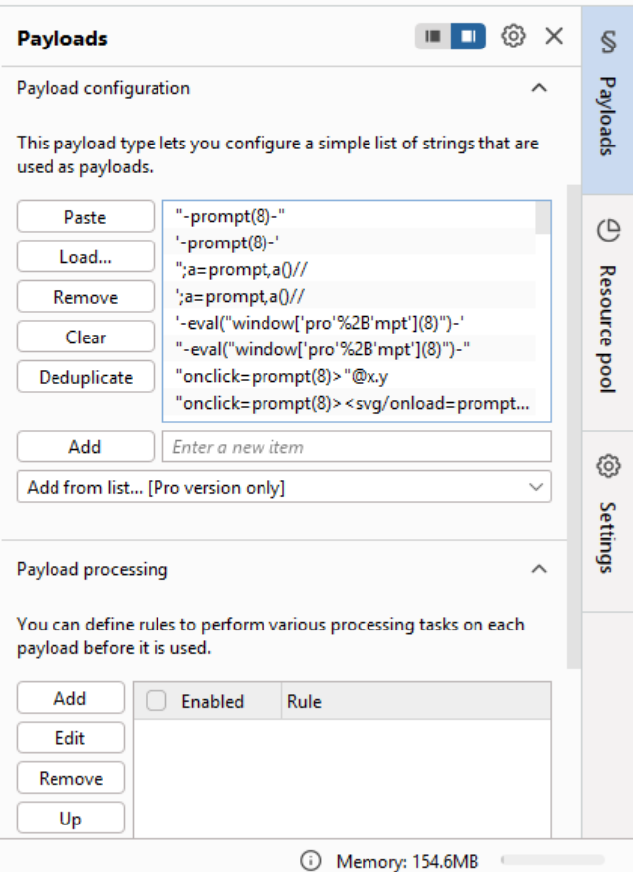

1. Start the attack and analyse responses for vulnerabilities.

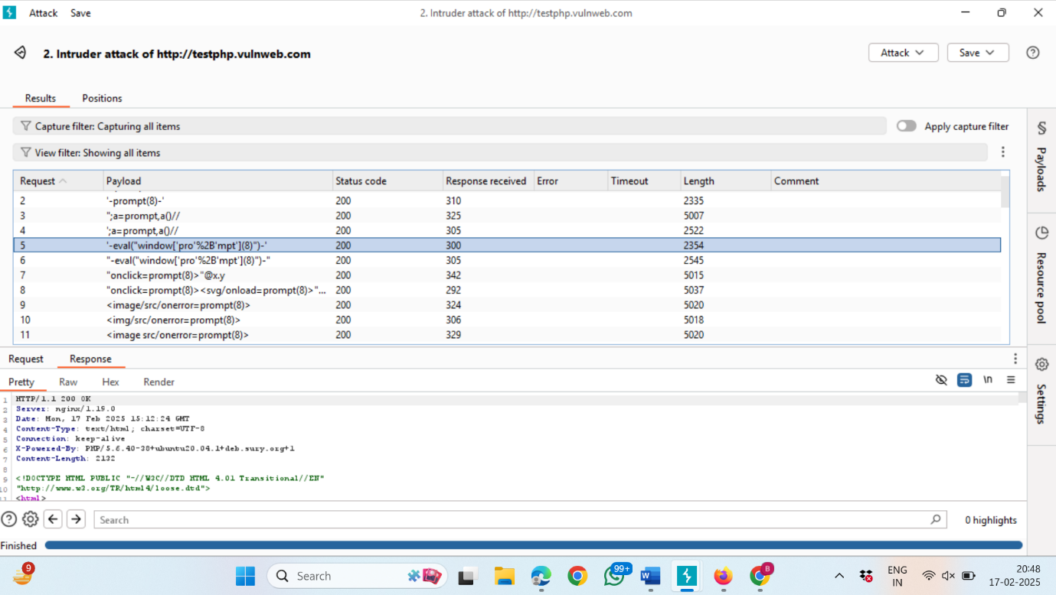

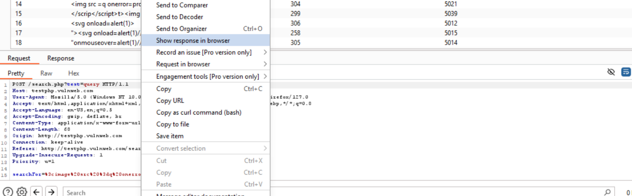

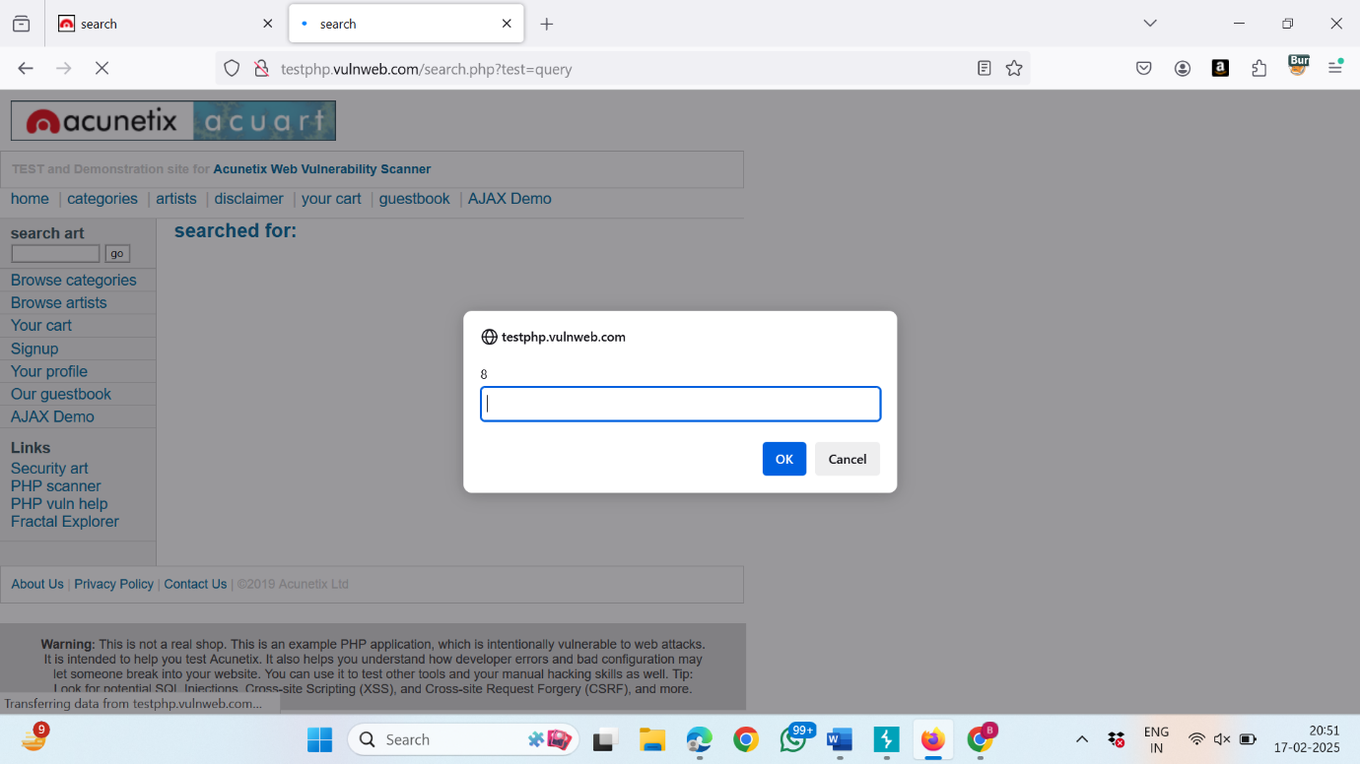

Burp Intruder is used for penetration testing, brute-force attacks, and automated fuzzing of input fields.

**Burp Encoder/Decoder**

The Burp Decoder assists in encoding and decoding text and provides Encoding and Decoding formats in all these:

* Plain
* URL
* HTML
* Base64
* ASCII
* Hex
* Octal
* Binary
* Gzip

It also provides Decoding & Encoding of various hashes such as:

* BLAKE2B-256
* GOST3411
* KECCAK-256 and many more

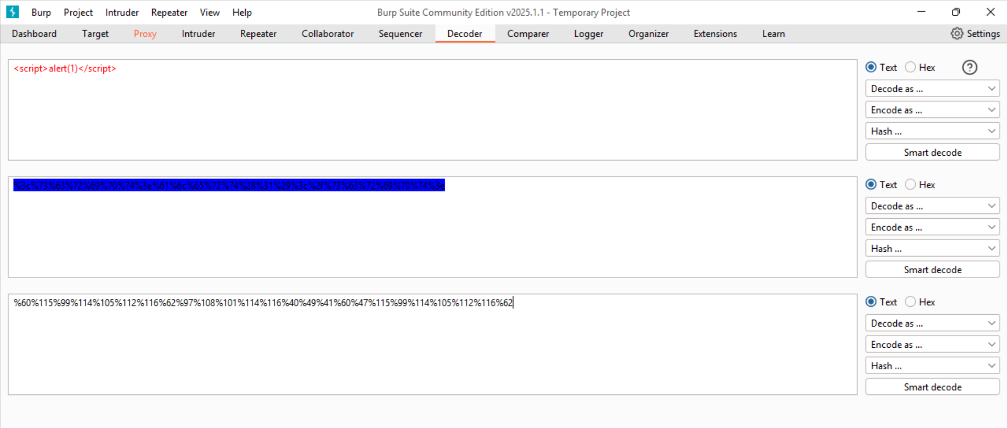

**Burp Comparer**

The Burp Comparer is a tool for comparing differences between two sets of data or responses from an application. This tool can easily help find the changes between the data or responses.

1) Send any two responses to Burp Comparer

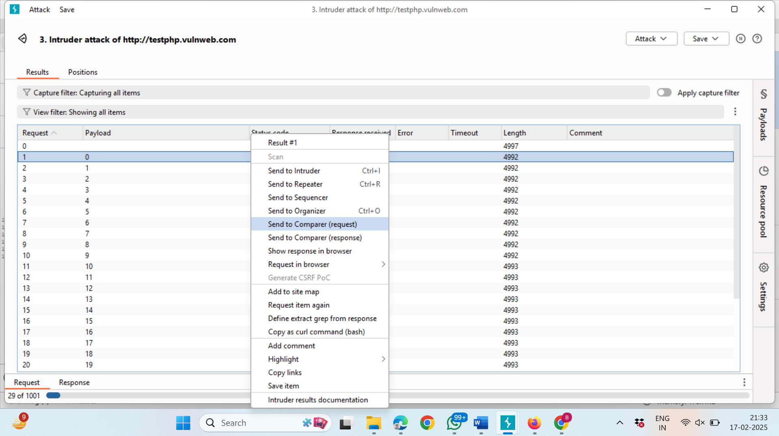

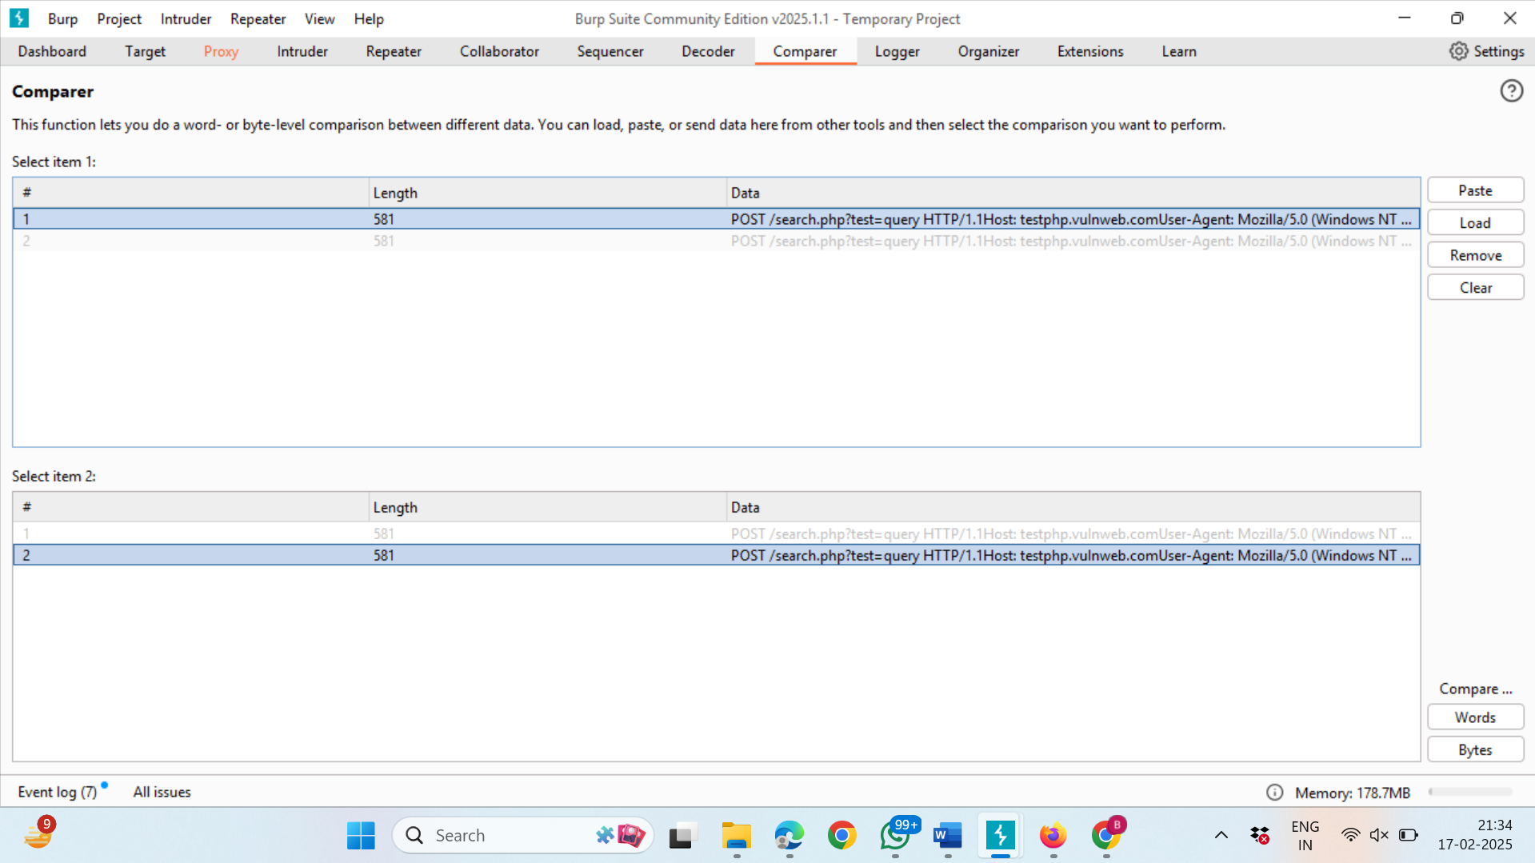

2) In the compare section, click on Words.

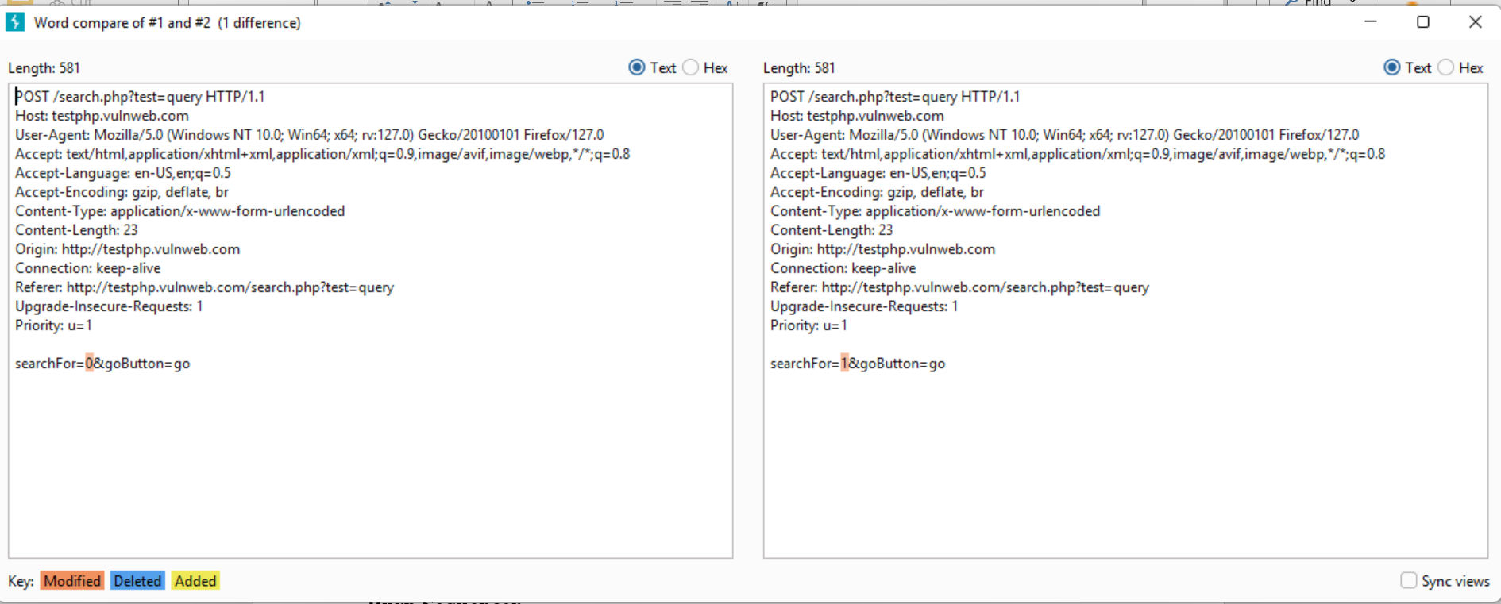

**Burp Target**

Burp Target provides an overview of the application's structure by mapping out URLs, endpoints, and parameters. It helps testers navigate the application's attack surface efficiently.

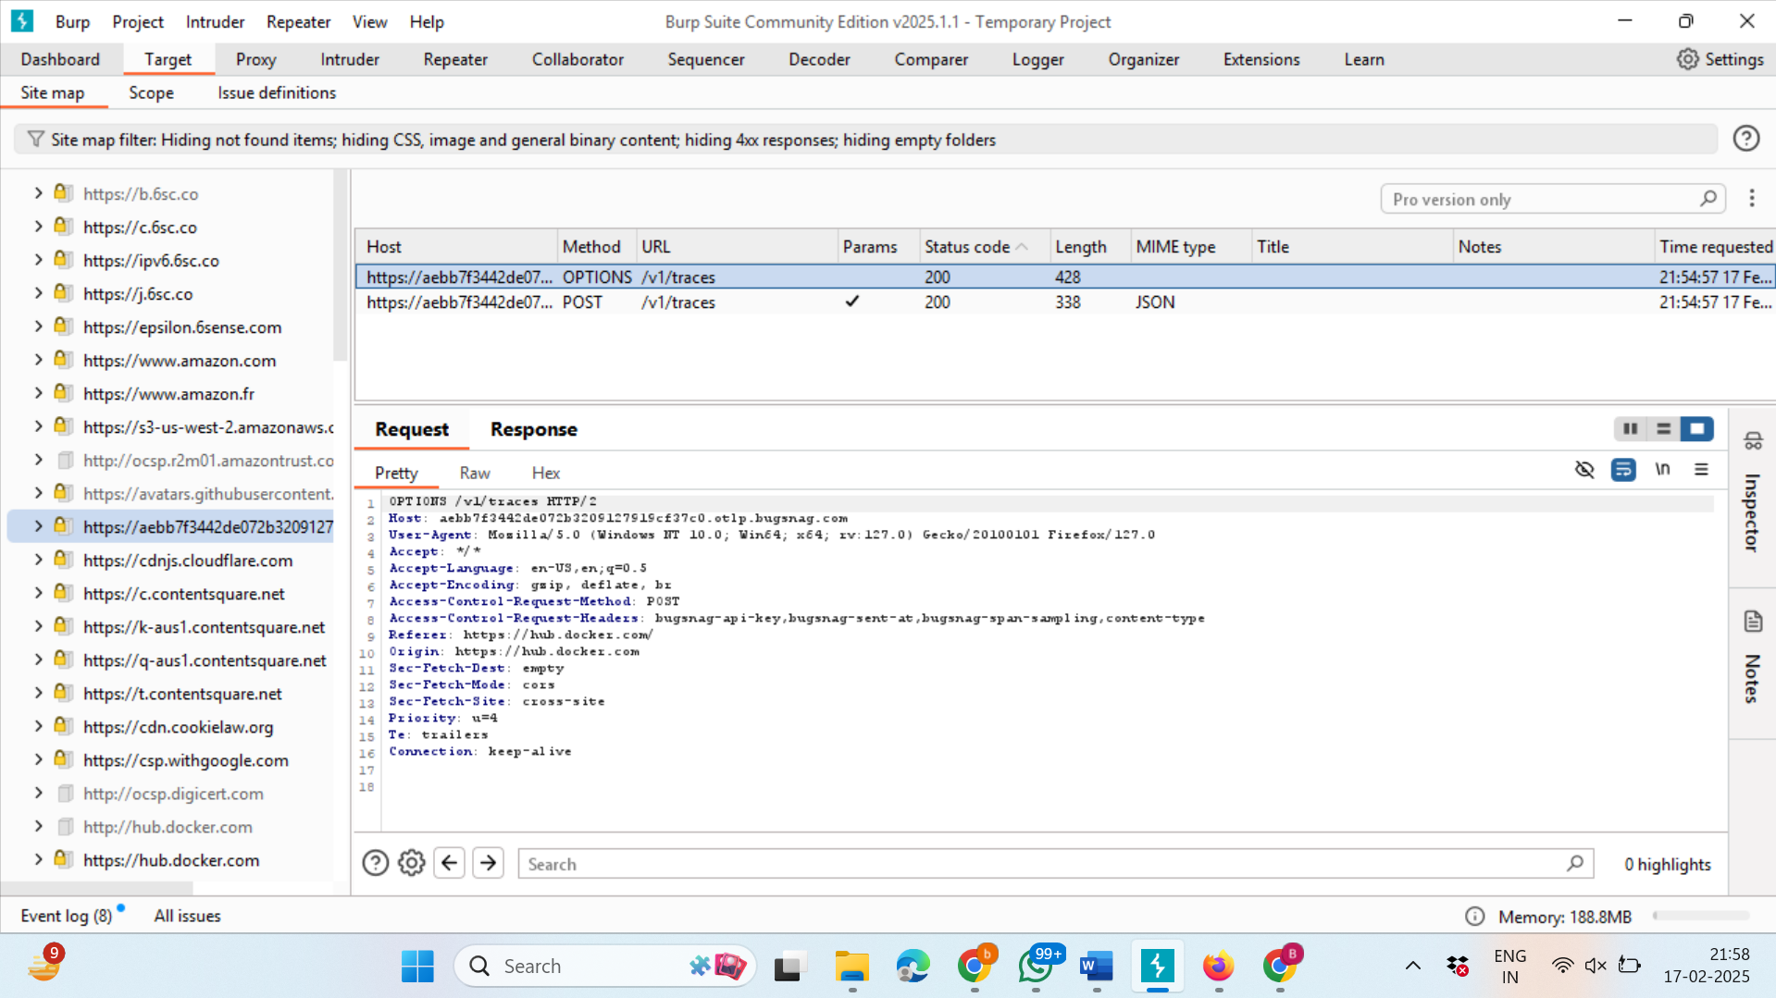

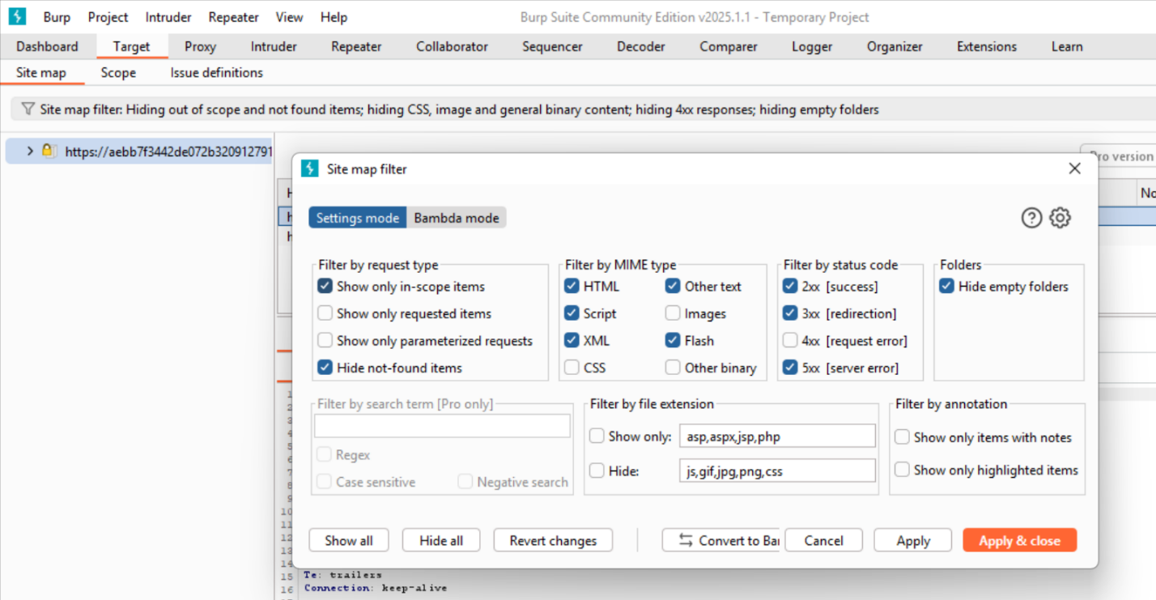  
**Limitations:**

Burp Suite is a powerful tool for web application security testing, but it does have some limitations, including:

1. **Complexity for Beginners**: The tool can be overwhelming for beginners due to its advanced features and options.
2. **Performance Issues**: It may become slow or resource-intensive when handling large or complex web applications.
3. **Limited Support for Non-HTTP Protocols**: Burp Suite primarily focuses on HTTP/HTTPS and lacks native support for protocols like FTP, SMTP, or WebSocket.
4. **Expensive Professional Version**: The free version has limited features, and the Professional version comes with a high price tag.
5. **Limited Automation**: While it supports automation via APIs, it lacks out-of-the-box automation features compared to other tools.

**Conclusion:**

Burp Suite stands as a cornerstone in the realm of web application security testing, offering a robust and versatile platform for identifying, analyzing, and exploiting vulnerabilities. Its comprehensive suite of tools, including Burp Proxy, Repeater, Intruder, Encoder/Decoder, and Comparer, empowers security professionals to conduct thorough and efficient security assessments. By acting as an intermediary between the client and server, Burp Suite enables users to intercept, inspect, and manipulate HTTP/HTTPS traffic, making it an indispensable tool for ethical hackers, penetration testers, and security researchers.

The **Burp Proxy** tool, with its ability to intercept and modify requests in real-time, is particularly valuable for identifying vulnerabilities such as SQL injection, Cross-Site Scripting (XSS), and broken authentication mechanisms. Meanwhile, **Burp Repeater** allows for meticulous manual testing, enabling testers to tweak parameters, headers, and payloads to analyze server responses in detail. This is especially useful for testing complex vulnerabilities that require precise manipulation of requests.

**Burp Intruder** further enhances the testing process by automating the delivery of customized payloads, making it ideal for brute-force attacks, fuzzing, and identifying injection vulnerabilities. The **Encoder/Decoder** tool simplifies the handling of encoded or obfuscated data, while **Burp Comparer** provides a straightforward way to identify differences between responses, aiding in the detection of subtle changes in application behavior.

Despite its many strengths, Burp Suite is not without limitations. Its complexity can be daunting for beginners, requiring a solid understanding of web security concepts and the tool itself. Additionally, the tool can become resource-intensive when dealing with large or complex web applications, potentially leading to performance issues. The lack of native support for non-HTTP protocols, such as FTP or SMTP, may also limit its applicability in certain scenarios. Furthermore, while the free version of Burp Suite offers a range of features, the full capabilities of the tool are only available in the Professional version, which comes with a significant cost. This may make it inaccessible for some users or organizations with limited budgets.

Another limitation is the tool's limited out-of-the-box automation capabilities. While Burp Suite does provide an API for automation, it may require custom scripts or extensions to achieve the same level of automation offered by other security tools. This can be a barrier for teams looking to integrate Burp Suite into continuous integration pipelines or automated testing workflows.

Despite these limitations, Burp Suite remains a powerful and widely-used tool in the field of web application security. Its ability to provide both automated and manual testing capabilities, combined with its extensive feature set, makes it a go-to solution for security professionals. Whether used for identifying vulnerabilities, analyzing traffic, or debugging API communications, Burp Suite continues to play a critical role in ensuring the security of web applications.

In conclusion, while Burp Suite may have its challenges, its strengths far outweigh its limitations. For those willing to invest the time to master its features, Burp Suite offers unparalleled capabilities for conducting thorough and effective security assessments. As web applications continue to grow in complexity, tools like Burp Suite will remain essential for safeguarding digital assets and ensuring the integrity of online systems.